From ‘The Safeguard of Sailors’ or ‘The Great Rutter’ 1594

Pg 43:

'Item, when Wight beareth northwest from you, and
that you are foure leagues from the land, there you shall
have 35 fatham, and the ground is great rough stones.

He that will saile in at the east end of Wight, let him
take heed of the Owers, and fetch the sholding of the west
side of the deapth before saint Ellins Church, and there
he may ride at seven or eight fatham. And he that will
saile in, let him bring the Lime Kill that lies above
Porchemouth, and the steeple of Porchmouth in one, and
so sale in, keeping two third parts of the chanell on the
Larboard side, and sail in so to Calshot.'

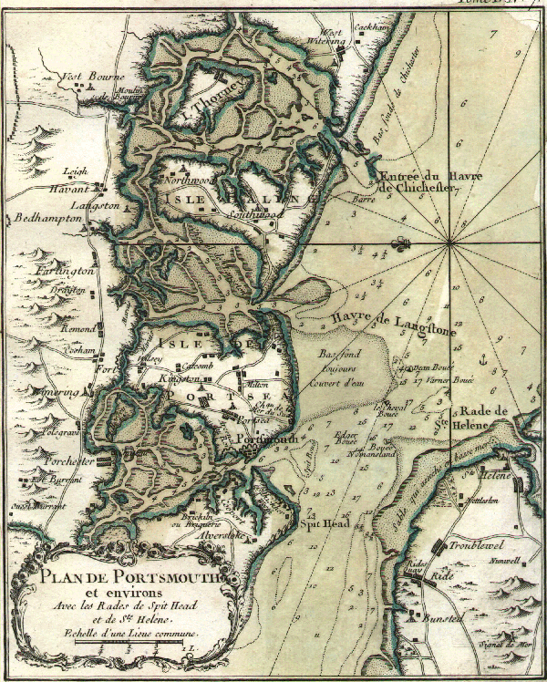
French chart of the eastern entrance to the Solent about 1750. Note the anchorage off
St Helens (still used today) as are the names and positions of the sea buoys (Warner,
Dean Elbow, Horse etc).

'At the east end of Wight, a northwest moone makes the
entrie of the first quarter of the floud.

He that will saile in at the west end of Wight, he must
looke well to the tide, for the floud sets verie sore upon the
Needles, and the ebb likewise westwards upon the Swin-
gilles, and chalkie rocks, which lies westwards of the
Needles, and is very narrow betweene the Needles and the
Swingilles, and let him directlie saile with the Needles, e-
ven till he come fast by them, and saile in verie neere them,
and when he is once within the Needles, then let him keepe
off from the land before him, bicause of the rockes called
the Wardens, which lies on Wight side neere the shore.
And he that will ride under the Beachy which lies on
the other side, let him ancker at seven fatham, and if he
will go anie farther in, let him keepe two third parts of the
channell towards the maine land, and saile so in till hee
come before the village of Yermouth, where the new bul-
warke stands upon Wight side. And if he will saile up to
Raushot, then he must saile on till he may see the towne of
Hampton appear without the Abbey, and ancker nearest
to the west part of Raushot.
He that will ride without Hurst by the Needles, let him
beere in and ancker before the village in the north cha-
nell, at three fatham at lowe water, and he shall have the
needles south southeast from him, and at a deepe tide, the

floud doth not rise there above one fatham.'

